LAB 3 – OOP

Anesu Njove

1. All the actors whose last name is Allen

1. All the actors whose last name column has a value DAVIS, and the row’s first name has a value SUSAN.

1. All actors with the last name Davis OR Allen

1. All the number of categories which have a name that does not start with the letter A.

1. All actor names and name of each film title there were in

1. Return the title, release year, and category of all movies. 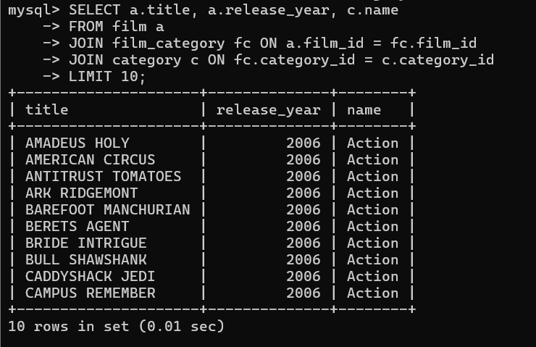
2. Return how much JOHNNY TURPIN has spent on movie rentalsA computer screen with white text

   Description automatically generated
3. Return the name of the customer that has spent the most of movie renntals, include the amount they have spent. 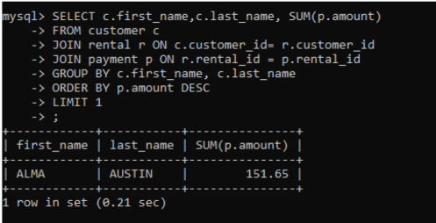
4. Return all movie title, release year, actor name and category where the actor first_name is ‘Sean’A screenshot of a computer

   Description automatically generated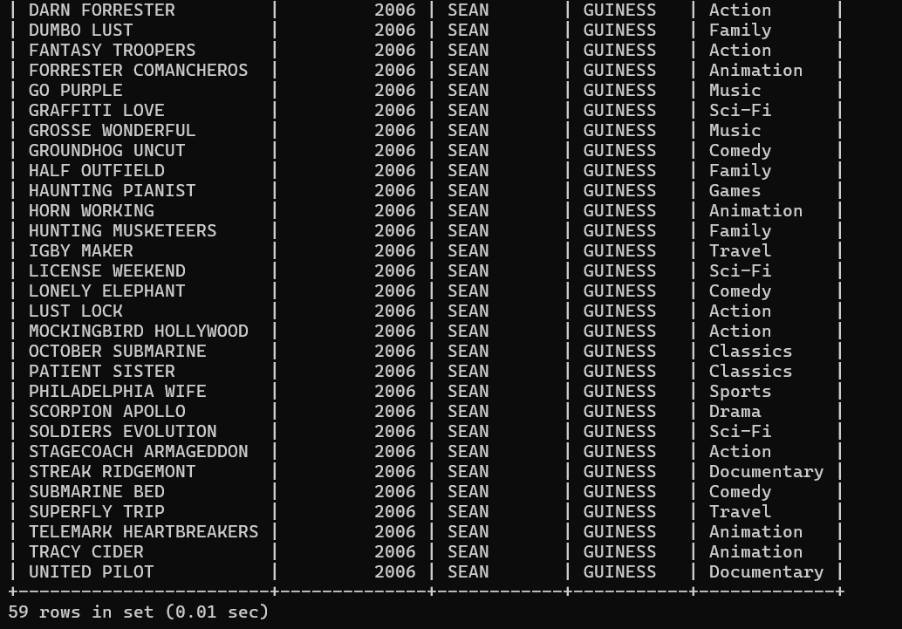
5. Explore the database and create ten more challenging SQL statement, something different to the above.